
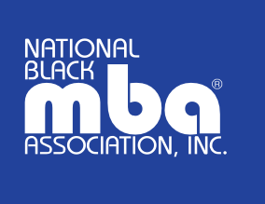

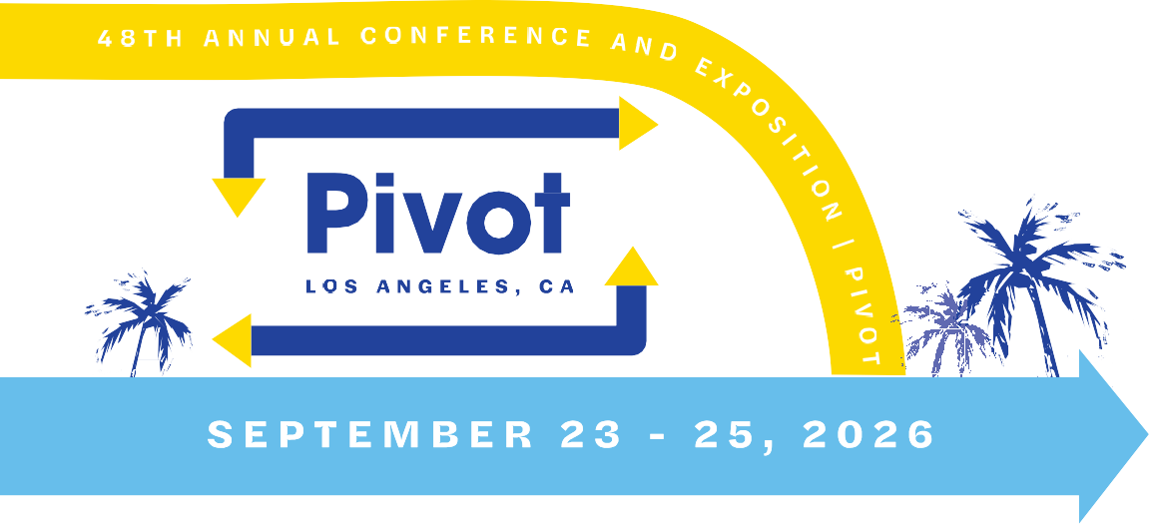

Dear [Manager’s Name],

I am writing to request your support in attending the 2026 National Black MBA Association (NBMBAA) Annual Conference & Career Expo — PIVOT, taking place September 23–25, 2026. As an active member of the NBMBAA, I view this event as an important opportunity for professional growth and organizational impact.

The NBMBAA Conference is the premier gathering for Black professionals in business and leadership, attracting thousands of executives, thought leaders, and corporate partners across industries. This year’s “PIVOT” theme focuses on leadership agility, innovation, and career advancement — all of which align closely with our company’s goals around professional excellence and inclusive leadership.

By attending, I aim to:
- Gain new insights and strategies from business leaders and industry experts.
- Explore professional development workshops focused on innovation, leadership, and emerging market trends.
- Build relationships with peers, mentors, and potential partners who can contribute to our company’s broader business objectives.

I respectfully request your approval for time off to attend the conference and, if possible, partial financial support to help offset registration, travel, and lodging costs. Upon returning, I will provide a summary of key takeaways, relevant resources, and actionable ideas that could benefit our team and organization.

Thank you for considering this request. I’m confident that participating in the 2026 NBMBAA PIVOT Conference will enhance my professional capabilities and reinforce our shared commitment to continuous learning, leadership development, and diversity in business.

Sincerely,
[Your Name]

